# b1511.06434【ICLR16‘】

related work gives several good papers in different aspects.

features expression part with the method of unsupervised learning gives a paper which had a good performance by pre-procession.

this work had some detail waited to discuss in the future work of this team.

obviously approximate 80% accuracy could not be used for practical purpose.

there is a instable problem remaining, expecting the following experiment. And I doubt that I already have seen these reports on these results.

INSIGHT:

1\ a DCGAN model structure.

2\ several applications about how to use the features extracted from discriminator and generator.

proposal:

1\ still a GAN, but add a feature control connection, this feature can be human pre-determined knowledge, and control could append parameter or not.

2\ attention mechanism can be used in graphic recognition, can used attention mechanism instead of pooling

3\ don’t forget concept of frequency domain analysis.

# srivastava15

through this is a rnn model, giving a generative model scheme, then should read the reference paper on generative model.

choices of output and loss function is important

if the generative sequence model is going to predict future sequence, we should consider that the future sequence isn’t a absolute resolution, referring to adding come noise or speech translation.

is the way getting the compressed representation similar to word embedding truly acquired ? No

maybe the unsupervised encoding procedure and supervised learning procedure with a few of data should not be separated.

embedding model can give inspirations.

points of my thoughts:

* enforcement learning
* adversarial learning
* attention mechanism (inspiration by word embedding, future and past)
* local search (get a model having local field parameters optimization)
* evolution algorithm
* elaborate loss function
* connection between encoder and decoder / generator and discriminator
* visual tracking (step circle and frequency characteristics)
* spatial normalization
* except denseNet, there is only squeezeNet in torchvision.

# Wang_Unsupervised_Learning_of_ICCV_2015_paper

a lot of pre-trained work

two stage in the training process.

practically, this method used labeled data, and the amount is proportional to the complexity of problem.

INSIGHT:

in fault classification, we can use output of Siamese net as feature representation.

# 5548-discriminative-unsupervised-feature-learning-with-convolutional-neural-networks

how to use data: augment

mention to self-training and entropy regularization

# matt_cvpr10

deconvolution net \ convolution transpose

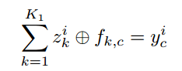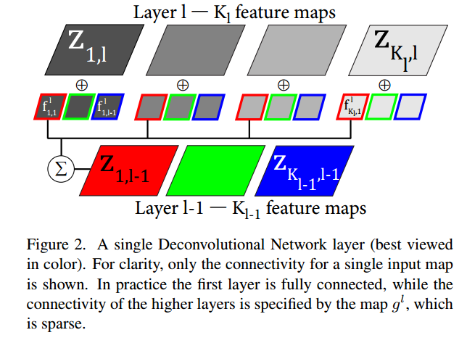

through changing the size of filter, feature map in each layer can produce a larger input.

# 1605.09782

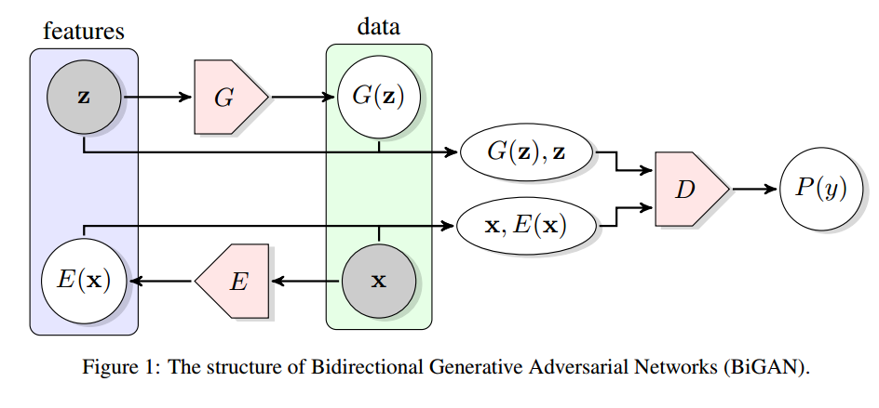

# **improve GAN performance，作者为 Jonathan Hui**

与其他深度网络相比，GAN 模型在以下方面可能会受到严重影响。

* 不收敛：模型永远不会收敛，更糟糕的是它们变得不稳定。
* 模式崩溃：生成器生成单个或有限模式。
* 慢速训练：训练生成器的梯度会消失。

作为 GAN 系列的一部分，本文探讨了如何改进 GAN 的方法。 尤其在如下方面，

* 更改成本函数以获得更好的优化目标。
* 在成本函数中添加额外的惩罚以强制执行约束。
* 避免过度自信和过度拟合。
* 更好的优化模型的方法。
* 添加标签。

解决方法：

特征匹配

微批次鉴别（微批次鉴别使我们能够非常快速地生成视觉上吸引人的样本，在这方面它优于特征匹配）

单面标签平滑（避免鉴别器过度自信（过拟合））

历史平均（强制收敛）

经验回放 （避免短时过度优化，强制收敛）

使用标签（CGAN）

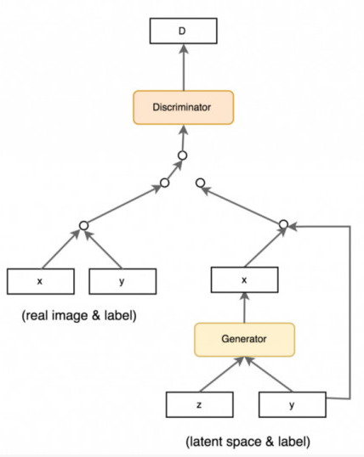

成本函数（**\***important）

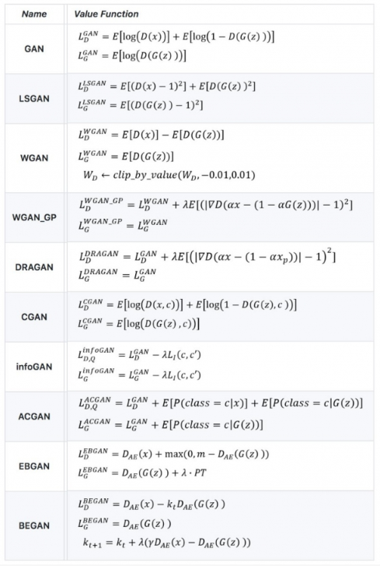

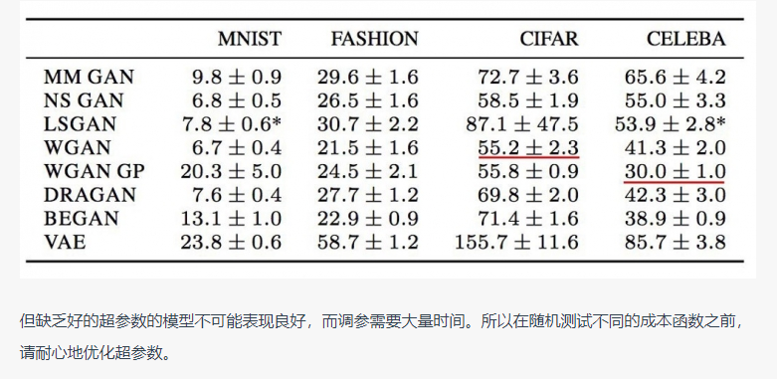

## 实现技巧

* 将图像的像素值转换到 -1 到 1 之间。在生成模型的最后一层使用 tanh 作为激活函数。
* 在实验中使用高斯分布对 z 取样。
* Batch normalization 可以让训练结果更稳定。
* 上采样时使用 PixelShuffle 和反卷积。
* 下采样时不要使用最大池化而使用卷积步长。
* Adam 优化通常比别的优化方法表现的更好。
* 图像交给判别模型之前添加一些噪声，不管是真实的图片还是生成的。

## Virtual batch normalization (VBN)

总结：

1在建GAN时，首先分别验证D能否在G不优化的情况下，提升real和fake的分辨能力，G在D不优化的情况下，能够提升fake不被分辨的能力（数据量从小到大）

2 验证G在有还原real的能力

3 保证以上能力时，注意调参

4 逐步解决出现问题的时候，增加了调控量，要保证D和G本来的功能不丢失，print各个指标用于分析。

5 对batch_size敏感度可能高

6 G的梯度消失问题